Linux ls command

The **ls** is the list command in Linux. It will show the full list or content of your directory. Just type *ls* and press the enter key. The whole content will be shown.

**Example:**

1. ls

Below, you can see, after entering ls command, we got the whole content list of /home/sssit directory.

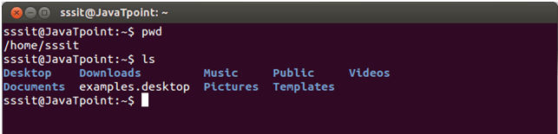

Linux ls command options

|  |  |
| --- | --- |
| **ls option** | **Description** |
| [ls -a](https://www.javatpoint.com/linux-ls#linux-ls-a) | In Linux, hidden files start with . (dot) symbol and they are not visible in the regular directory. The (ls -a) command will enlist the whole list of the current directory including the hidden files. |
| [ls -l](https://www.javatpoint.com/linux-ls#linux-ls-l) | It will show the list in a long list format. |
| ls -lh | This command will show you the file sizes in human readable format. Size of the file is very difficult to read when displayed in terms of byte. The (ls -lh)command will give you the data in terms of Mb, Gb, Tb, etc. |
| ls -lhS | If you want to display your files in descending order (highest at the top) according to their size, then you can use (ls -lhS) command. |
| [ls -l - -block-size=[SIZE]](https://www.javatpoint.com/linux-ls#linux-ls-l-block-size) | It is used to display the files in a specific size format. Here, in [SIZE] you can assign size according to your requirement. |
| [ls -d */](https://www.javatpoint.com/linux-ls#linux-ls-d-asterisk-slash) | It is used to display only subdirectories. |
| [ls -g or ls -lG](https://www.javatpoint.com/linux-ls#linux-ls-g) | With this you can exclude column of group information and owner. |
| ls -n | It is used to print group ID and owner ID instead of their names. |
| [ls --color=[VALUE]](https://www.javatpoint.com/linux-ls#linux-ls-color) | This command is used to print list as colored or discolored. |
| ls -li | This command prints the index number if file is in the first column. |
| ls -p | It is used to identify the directory easily by marking the directories with a slash (/) line sign. |
| ls -r | It is used to print the list in reverse order. |
| ls -R | It will display the content of the sub-directories also. |
| ls -lX | It will group the files with same extensions together in the list. |
| ls -lt | It will sort the list by displaying recently modified filed at top. |
| [ls ~](https://www.javatpoint.com/linux-ls#linux-ls-tilde) | It gives the contents of home directory. |
| [ls ../](https://www.javatpoint.com/linux-ls#linux-ls-dot-dot-slash) | It give the contents of parent directory. |
| ls --version | It checks the version of ls command. |

Linux ls -a command

It will give you the whole list of a directory including the hidden files also. In Linux, hidden files start with a dot (.) and can't be seen in the regular directory.

**Example:**

1. ls -a

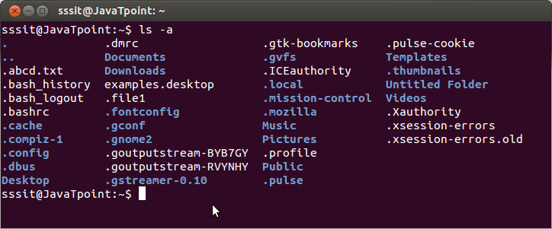

In the above example, you can see the whole list of files, including the hidden files.

Linux ls -l command

The ls command will only display the files. But if you want your files to be displayed in a long list format, then you can use ls -l command.

**Example:**

1. ls -l

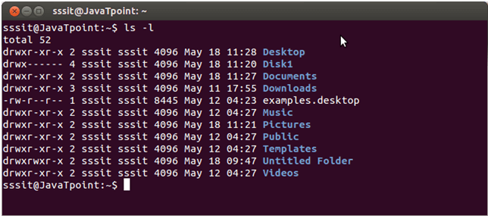

Here, as you can see the list in long list format.

**Columns above indicate specific things:**

* Column 1 indicates information regarding file permission.
* Column 2 indicates the number of links to the file.
* Column 3 & 4 indicates the owner and group information.
* Column 5 indicayes size of the file in bytes.
* Column 6 shows th date and time on which the file was recently modified.
* Column 7 shows the file or directory name.

Linux ls -l --block-size=[SIZE]

If you want to display the file size of your list in a particular format or size, then you can use this command. Just put the size in place of [SIZE] as per your requirement.

**Syntax:**

1. ls -l --block-size=[SIZE]

**Example:**

1. ls -l --block-size=M

Let's see the output below.

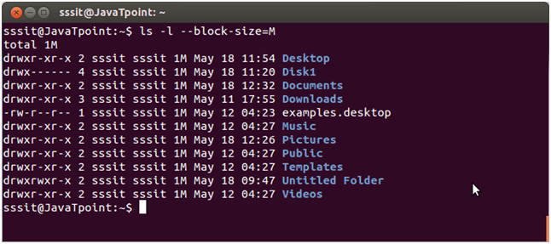

Here, all file size has listed in Megabyte.

**You can replace [SIZE] with the following measures:**

* K = Kilobyte
* M = Megabyte
* G = Gigabyte
* T = Terabyte
* P = Petabyte
* E = Exabyte
* Z = Zettabyte
* Y = Yottabyte

Linux ls -d */

If you only want to display the sub-directories excluding all other files, you can use this command.

**Example:**

1. ls -d */

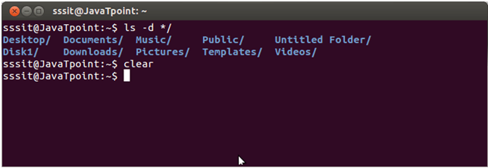

The above result only shows sub-directories excluding all the other files.

Linux ls -g

If you don't want to display the owner information in your list, then you can exclude this column with the help of this command.

**Example:**

1. ls -g

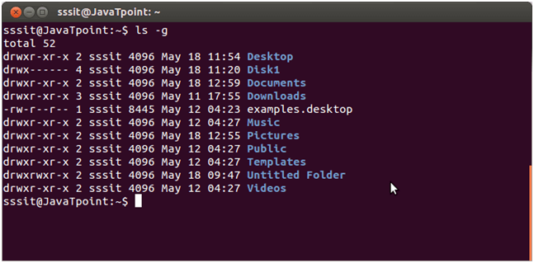

Here owner column is excluded.

Linux ls -lG

If you don't want to display the group information in your list then you can exclude this column with the help of this command.

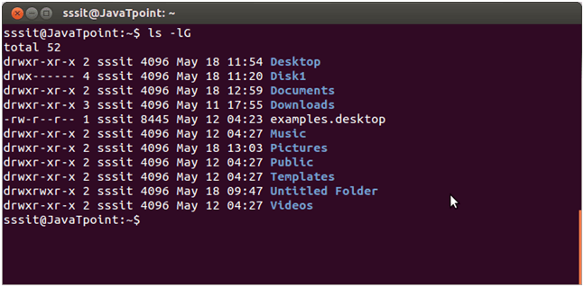

Here group column is excluded.

Linux ls --color=[VALUE]

This command is used to colorize and decolorize the list. If you replace the [VALUE] by 'auto', it will display the colored list. But, if you will replace the [VALUE] by 'never', it will decolorize the list.

**Syntax:**

1. ls --color=[VALUE]

**Example:**

1. ls --color=never
2. ls --color=auto

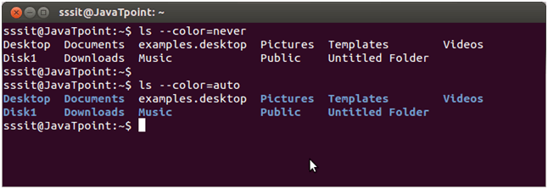

You can easily notice the difference between auto and never command in the above image.

Linux ls ~

Linux ls ~ command shows the contents of the home directory. Let us see the example of ls ~ command.

**Example:**

1. ls ~

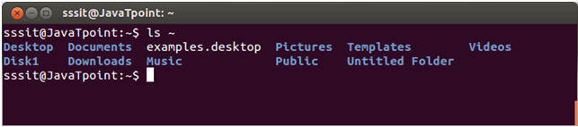

Linux ls ../

This command contains the list of the parent directory.

In the given example, our current directory is Downloads, and by using **ls ../** command, we have listed out the content of its parent directory "home directory".

**Example:**

1. ls ../

